Location Management Plan for:

Activity | Date Created/Edited | Editor (Name) | Version Number
Rock climbing/ Abseil | 27/02/25 | Kirstee Scarpellini | 1

Activity Area
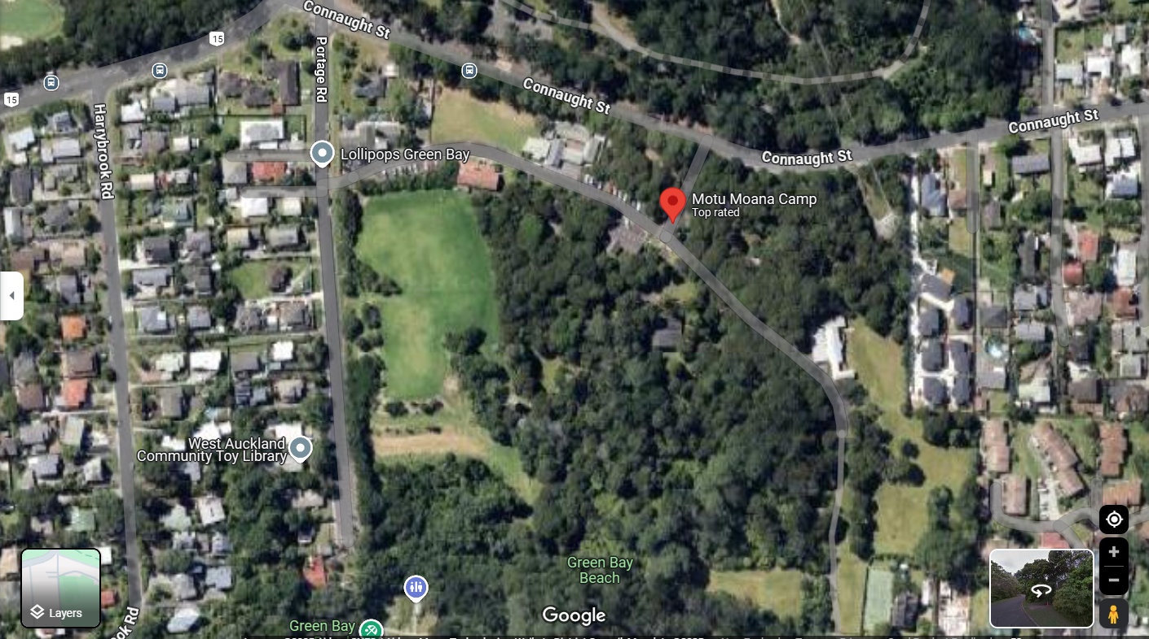

Location Specific Information
Address/directions | 90-140-142 Connaught Street,  Blockhouse Bay, Auckland
Site contacts | Gloria Clan  0800 667 2267  gloria.crann@scouts.nz
Permission/booking/costs | Booking to be made via the website https://www.motumoanacamp.co.nz/page60f782572fbd4b9164e7b1f9
Cell phone coverage | generally good dependant on the phone network provider
Access/parking | Access via the portage road. The driveway is next to Lollipops kindergarten.  Only one vehicle is allowed on site: Right-hand side, just past the cones.  Sign in on arrival
Emergency assembly point/ alternative ways in/out | assemble via access point
Onsite shelters | Shelter may be used on request.  But don't allow people to if there are other groups in.
Water sources | There is accessible drinking water in the bathrooms
Toilets | toilets onsite located in main building
Closest medical centres | Local Medical Centre  Name: White Cross New Lynn  Address:2144-2146  Great North Road,  New Lynn,  Auckland  0600  Hours: 8-8pm  Phone:09 828 8912
Closest medical centres | 24/7  Name: Auckland Hospital  Address:2 Park Road,  Grafton,  Auckland  1023  Hours: 24hrs  Phone: 09 367 0000

Additional information
Abseil Tower.
- A set of keys opens the tower gate.
- Many manageable hazards are walking up the tower, including low wooden beams.
- The top abseil that comes down the rock wall is closed due to rust.
- The first Abseil site is good to use with a horizontal pole, allowing for easy setup. Though it is high and should be reached carefully
- There is a slope for an easy descent.
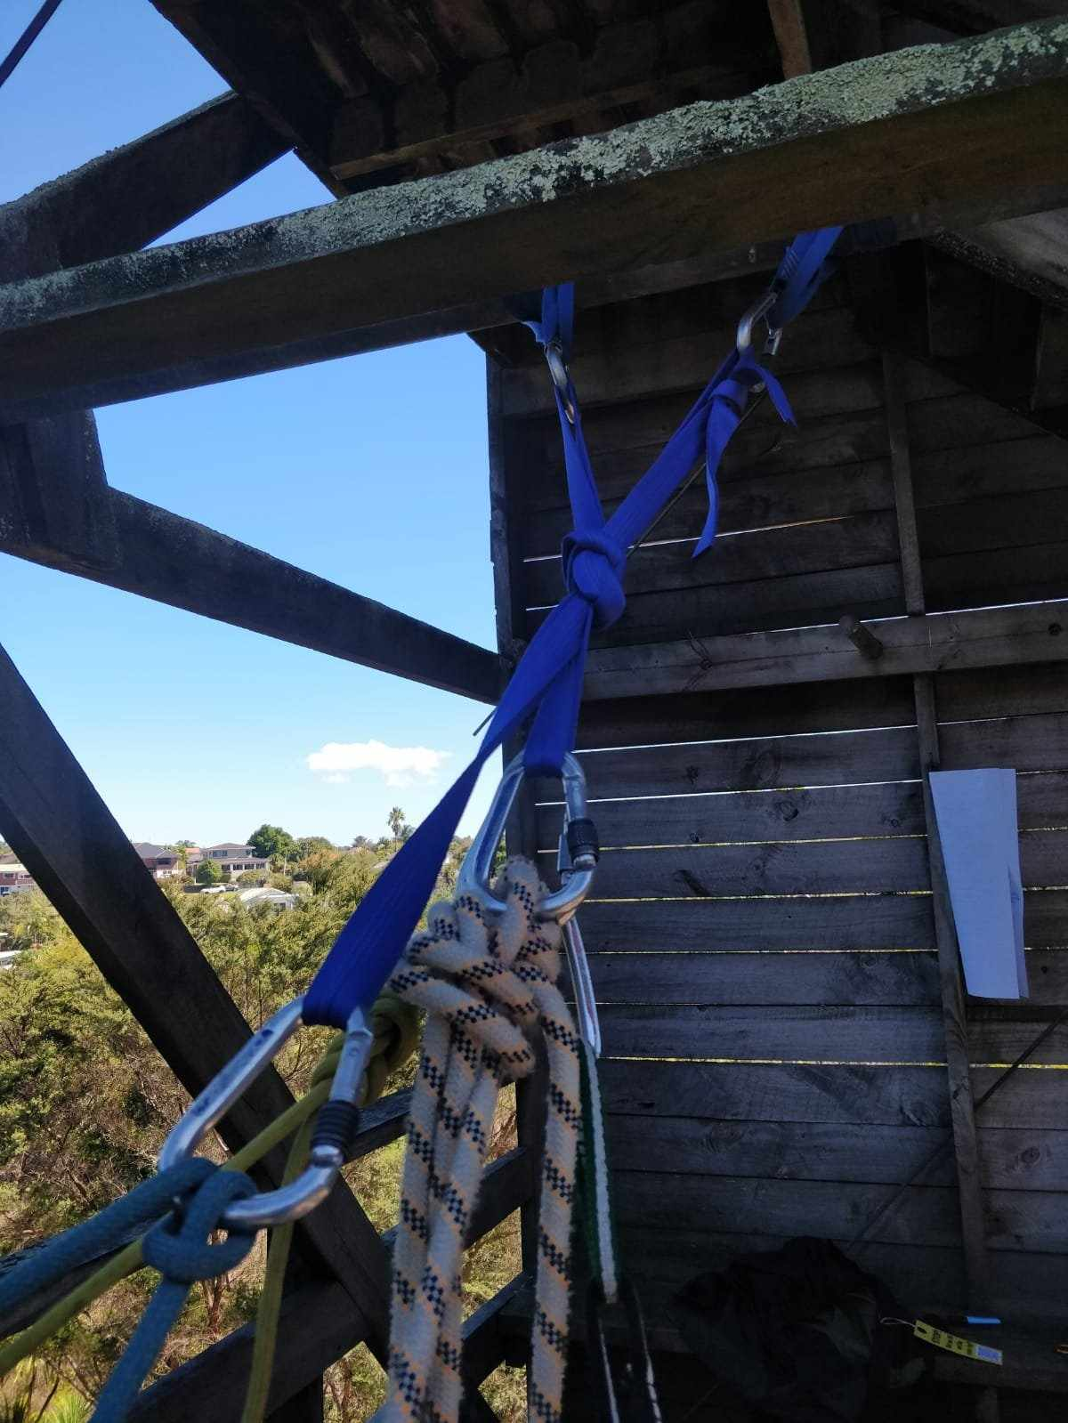

Rock wall.
- The rock wall is accessed with the duplicate keys as the Abseil tower.
- Set up is with pull cords.
- The anchors are off-centered for the first half, meaning if a student falls into their harness during the first half, they will swing and bounce.

Weather and Environmental Parameters
Rain | Frequent during winter. Check the MetService forecast, bring waterproof gear, and avoid low-lying flood-prone areas. shelter onsite
Wind | Strong westerly winds are common due to Auckland’s coastal exposure.
Lightning | low-moderate risk
Unstable rock | Low. The area has cliffs and coastal rock formations that can be prone to erosion.  Rockfalls are possible, especially after heavy rain

Natural Hazards
https://www.naturalhazardsportal.govt.nz/s/natural-hazard-risk/natural-hazards-in-your-area
Volcanic
Earthquake | Auckland is slightly seismically active so earthquakes are possible but unlikely
Tsunami | Blockhouse Bay is near the coast, but it's located inside the Manukau Harbour, which reduces direct tsunami impact.
Flooding | Heavy rain can cause flash flooding, the area is grassy and may become saturated
Landslide | surround areas are low-land

Site Specific Hazards
https://docs.google.com/spreadsheets/d/1oXZfpvv4rwzrFrW4a7jt3t7cFGkKw8J-1l4_qiVRg-A/edit?usp=sharing
Area | Location | What is the harm or loss | Describe what could cause the harm or loss | Uncontrolled risk rating | Eliminate or minimise | Controls to To minimise or eliminate the harm or loss | Residual risk rating

Rock climbing | 27/02/2024 | Green Bay | Motu Moana | Person | Spinning Holds | Medium | Brief participants to be aware of spinning holds. It is not possible to tighten the holds so ensuring the participants are aware of the potential movement of holds and the risk this poses (very low) to ensure that they don't get too spooked. | Low
Rock climbing | 27/02/2024 | Green Bay | Motu Moana | Person | Climbing Routes not following the line of the ropes. | Medium | With the new system that has been set up at the top of the tower. Means that climbers will swing if they fall off. Participants could be spooked if they are unaware. Ensure that participants are aware of the potential for swinging to take place. The system does not allow for the rope to rub excessively. | Low
Abseiling | 27/02/2024 | Green Bay | Motu Moana | equipment | Missing Trapdoor. | High | The trapdoor that prevents access to the 1st abseil platform is not in place. If participants enter the tower unaccompanied they could access the edge. Ensure that the door to the tower is locked when the tower is not in use to prevent unauthorised access. When the abseiling is happening. participants should be accompanied. There is a chain that should be in place that should be in place and managed as a physical barrier to prevent participants from accessing the edge environment. | Medium
Abseiling | 27/02/2024 | Green Bay | Motu Moana | equipment | Heavy Trapdoors | High | Ensure all trap doors are held open with the hook and latch ensuring that it will not fall unexpectedly. | Medium
Rock climbing | 27/02/2024 | Green Bay | Motu Moana | equipment | Barb wire on fence | Medium | Barb wire at the top of the fence that prevents access to the climbing wall when not in use could potentially become a hazard for climbers. The climbs are far away from the wire and the natural fall line for the ropes are well away from the wire but it should be something that instructors are aware of. | Low
Rock climbing | 27/02/2024 | Green Bay | Motu Moana | environment | Concrete tunnel | Medium | Unsupervised participants could hurt themselves. Participants should be alerted and warned not to use this feature. | Low

Abseiling | 27/02/2024 | Green Bay | Motu Moana | equipment | Anchor Bar - Top of Tower | High | DO NOT USE. due to deteriorated wood. It is waiting to be checked professionally. | Medium

